CLANN TARTAN

Colonel Gaffney’s Regiment
A Non-profit Scottish Living History Group

www.clanntartan.org

Enlist Today!

Make your Mark below!

Type of Membership:
⁪ Individual / Family $20.00
⁪ Student $10.00

Recruit’s Name:

_____________________________
Street Address:

_____________________________
City, State ZIP:

______ - _______ - ____________
Phone #

Email:

_________________________

Join the Regiment today!!

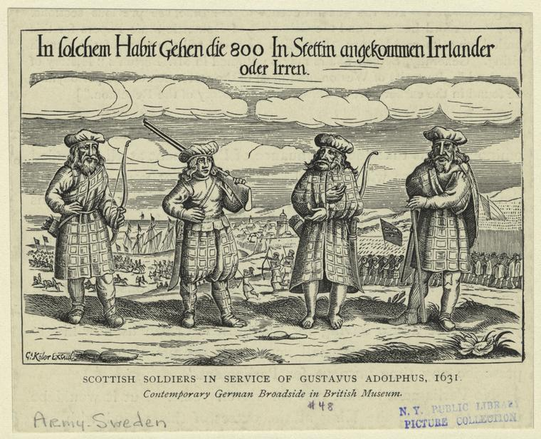

Fire a Matchlock

Wield a Sword

Cook over an open fire

Spin wool

Make Scotland proud!

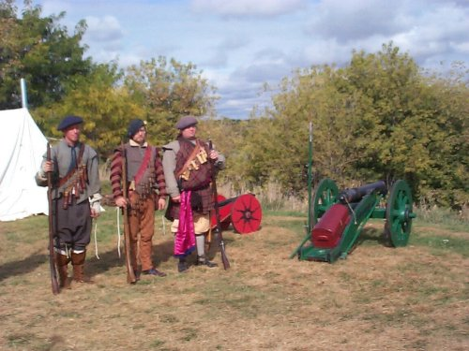ARE YOU TYRED OF EARNING ONLY SHILLINGS A YEAR?

ARE YOU TYRED OF GIVING MOST OF YOUR CROPS TO THE LANDLORD EVERY SEASON?

DO YOU WISH YOU KNEW WHAT WAS PAST THE FAR HILL?

Join Colonel Gaffney’s
Regiment of Pike and Shot.
See what lies over the ocean.
Travel, eat well and earn up to 6 Reichsthallers a month.

Take the coin from the Drumhead and place your mark in the companies register… The Colonel will provide everything you could ever need.
Bring your family – opportunities available to make extra money by working in the camp!

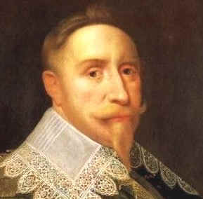
KING GUSTAVUS ADOLPHUS WANTS YOU!!!
From 1618 to 1648, Scotland’s greatest export was 50,000 to 80,000 Highland Scots, fighting for King Gustavus Adolphus.

We are a Living History group portraying everyday activities - military and camp life - in a Scottish encampment.

Colonel Gaffney’s Regiment of Pike and Shotte is a detailed recreation of a Scottish mercenary army, based in Scotland, recruiting soldiers to go to Europe and fight in what would later be called the Thirty Years War.

Camp life consists of soldiers as well as crafters, musicians, weavers, cooks, and more.
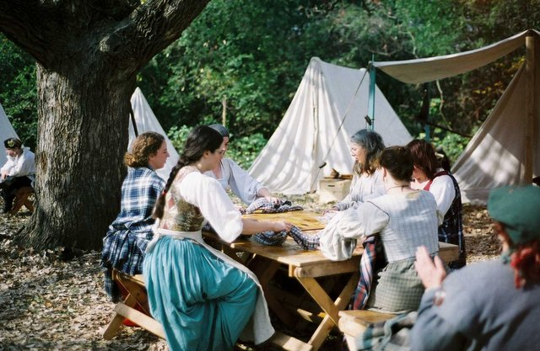

Clann Tartan is the parent company of the volunteer performance group called Col. Gaffney’s Regiment of Pike and Shotte. We are a 501c3 non-profit group established in 1987.

Our mission is to educate and entertain the public and ourselves in the history of Scotland between the years 1550 and 1750.

Members research various fields such as food, medicine, fiber, clothing, weaponry, military tactics, blacksmithing, horn working, political climate, music, dance, language, and we love to share our knowledge with other members via guilds, musters and drills. Participation is free to members and open to all skill levels.

Meals are provided at events unless otherwise announced. Members are also eligible to join any guild and social activities.

Excerpt from a letter penned by Sarient Major Forbs on the 4th of September, 1631, on the Continent during the 30 Years War:

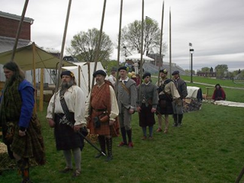

“The Kings Armie marched on the right hand of the Battle, and the Dukes on the left, and advanced in Battleray against the enemy; who began to playe despitefully with his Ordinance upon us which we cared not much for, but advanced forward with our ordinance likewise playing before us. They seeing us marching towards them, they advanced likewise towards us, and came so close one to an other that joining battalions together, wee came to pushe of pike and disputed the buysiness so longe, till it pleased God, that wee routed them, and gave us the victorie, by putting the Enemy to retreat with the Kings own Armie, but the Dukes Army was vily beaten back, and began to make a shameful flight, so that we were forced to send out horsemen after these that were beaten, and to relieve the Dukes men with our foote…”.

